Task on terraform-04
1. Watch Terraform-04 video.
2). Execute the script shown in the video.
Version constraints:
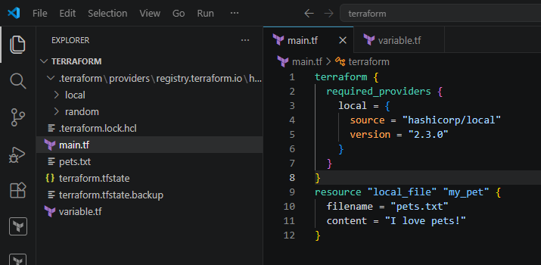
Here we can see that it is downloading the given version from the configuration:
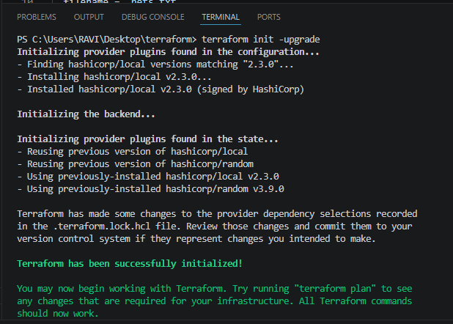
We can see the file has been created
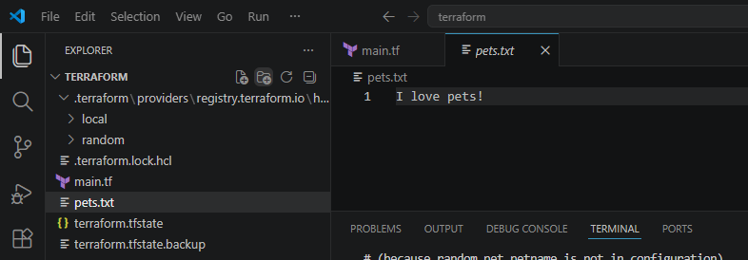
Now lets download different version:
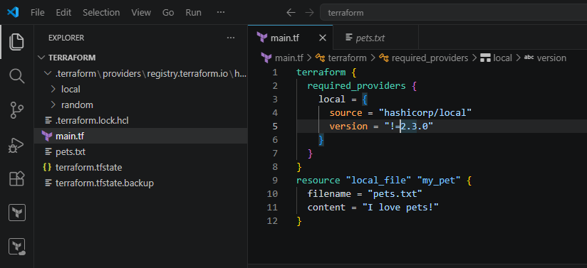
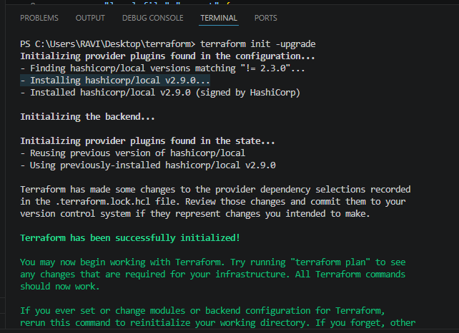
Now lets download for version less than 2.3.0
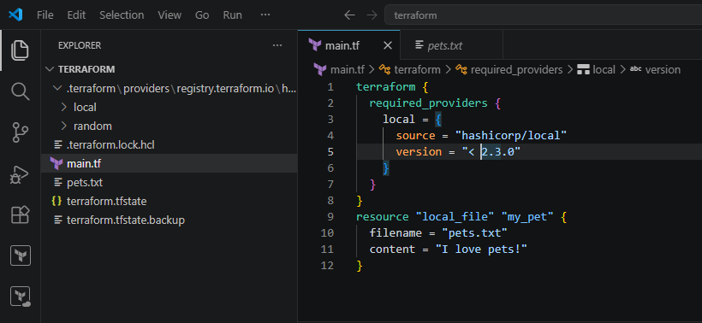
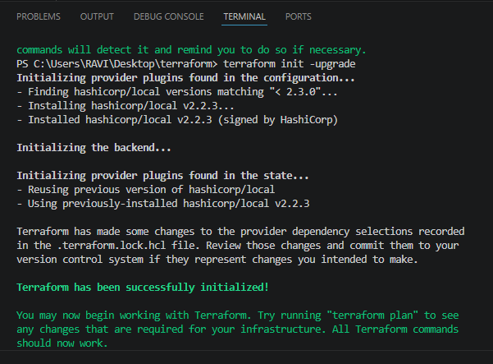
Also lets download the version greater than 2.3.0
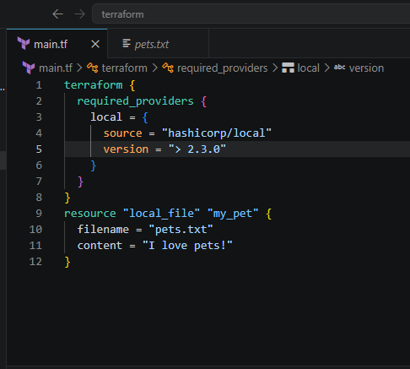
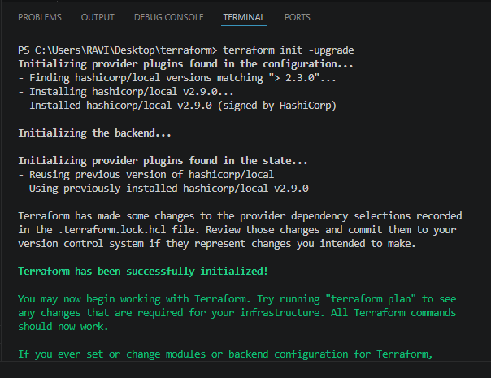
version = "~> 2.3.0" --> specific version or higher version.
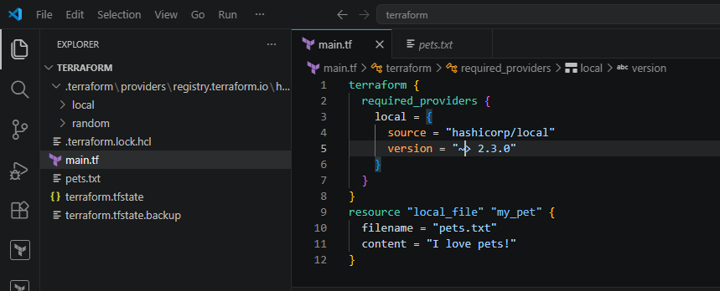
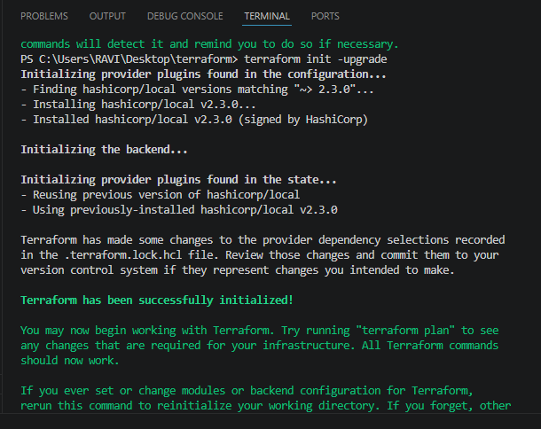
Data source
Data source is used to read the existing infrastructure, it won’t create any files.
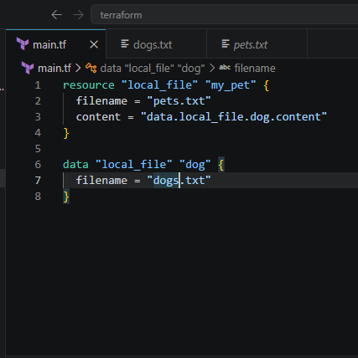
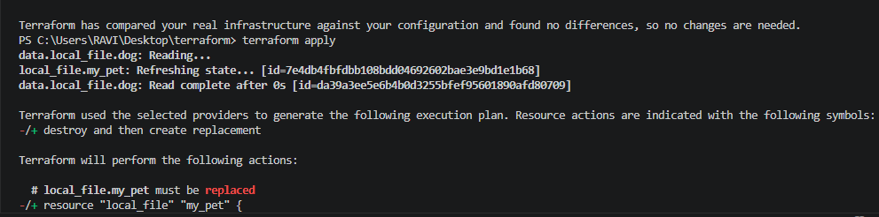
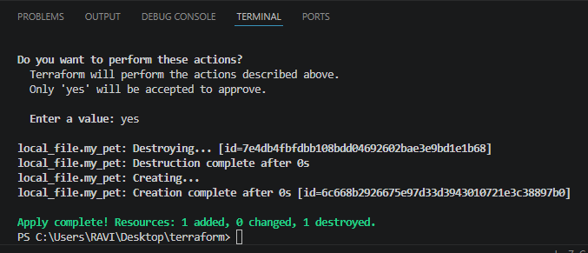
2). Execute the script shown in the video.
➢ Meta-Arguments:-
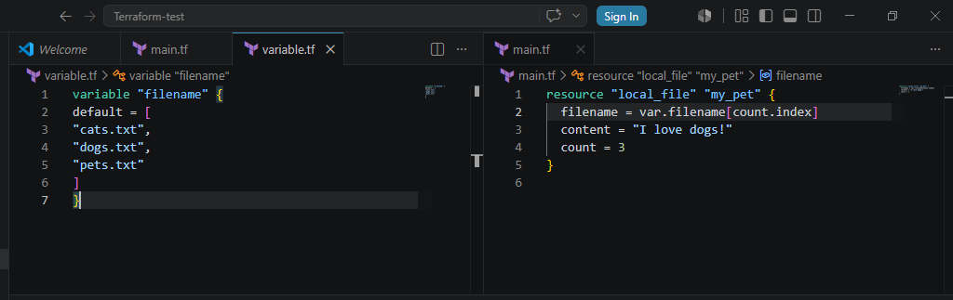
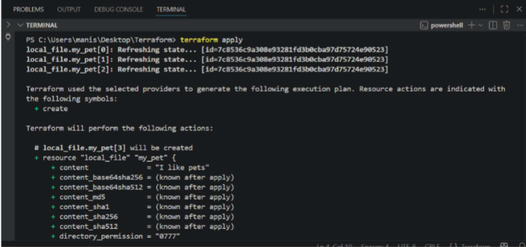
3 files were created
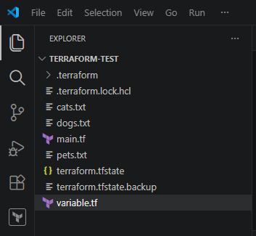
Now lets destroy one file – cats.txt
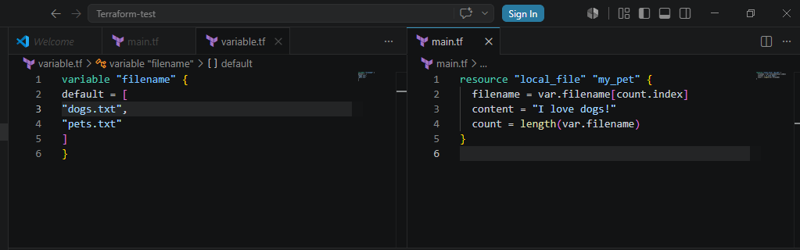
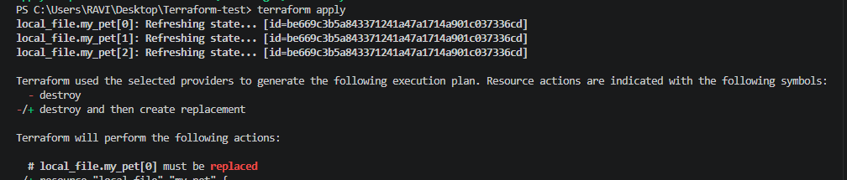
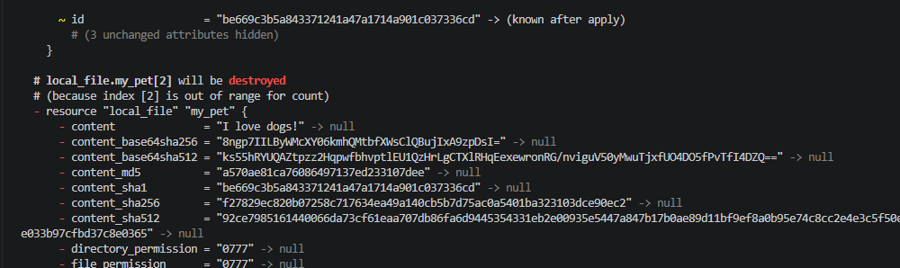
Files deleted successfully
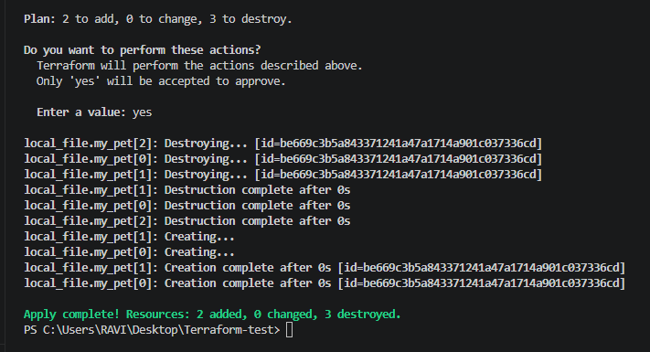
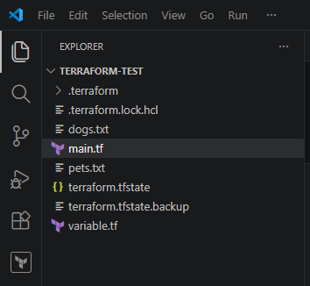
For_each
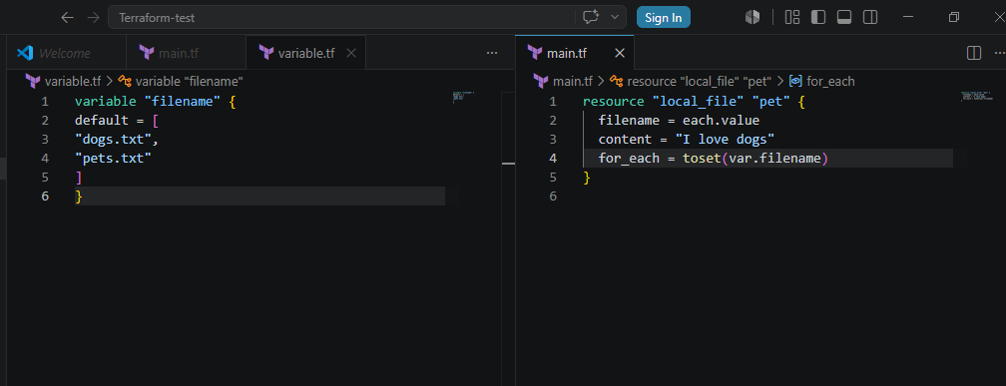
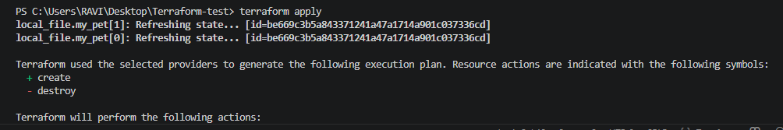
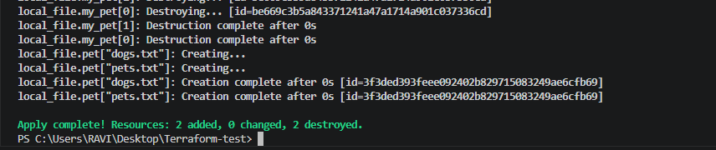
If we don’t want to use the inbuilt function we can include type in variable.tf
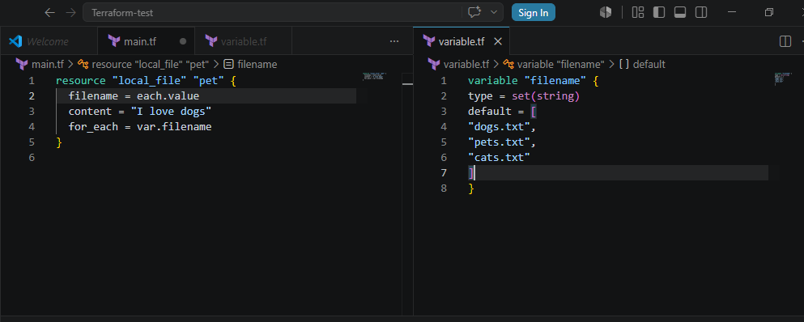
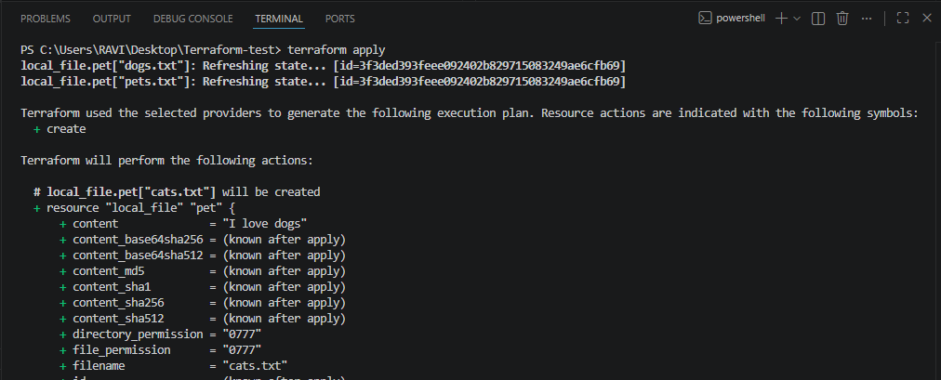
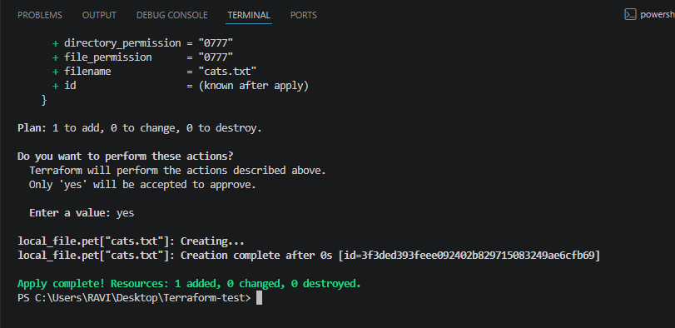
Lets create user and policy:-
provider "aws" {
region = "eu-north-1"
}

# Create IAM User
resource "aws_iam_user" "dev_user" {
name = "terraform"
}

# Create Custom IAM Policy
resource "aws_iam_policy" "custom_policy" {
name = "CustomS3ReadOnlyPolicy"
description = "Allow read-only access to S3 buckets"

policy = jsonencode({
Version = "2012-10-17"
Statement = [
{
Effect = "Allow"
Action = [
"s3:ListBucket",
"s3:GetObject"
]
Resource = [
"arn:aws:s3:::*",
"arn:aws:s3:::*/*"
]
}
]
})
}

# Attach Policy to User
resource "aws_iam_user_policy_attachment" "attach_policy" {
user = aws_iam_user.dev_user.name
policy_arn = aws_iam_policy.custom_policy.arn
}
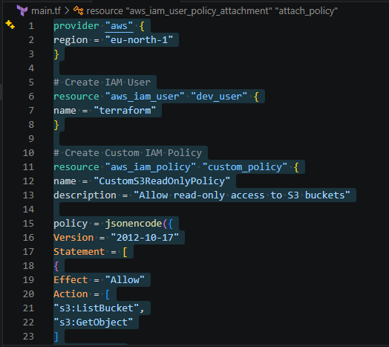
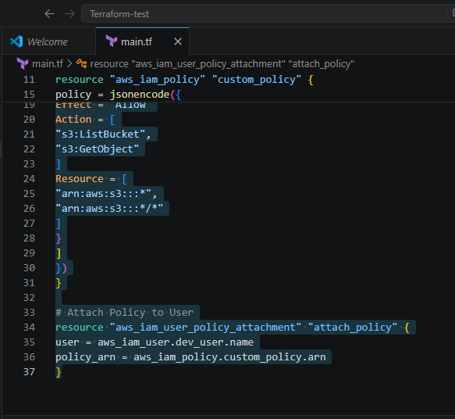
After this we need to do aws configure in the visual studio as shown below:
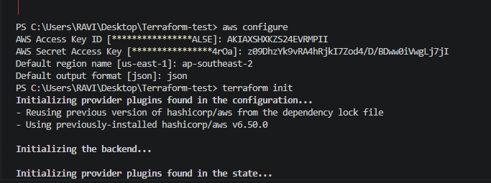
Terraform plan:
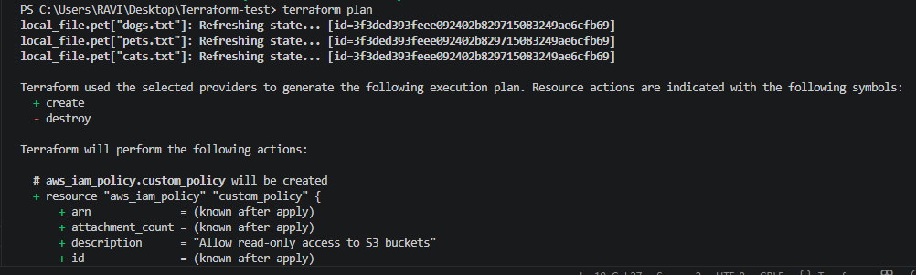
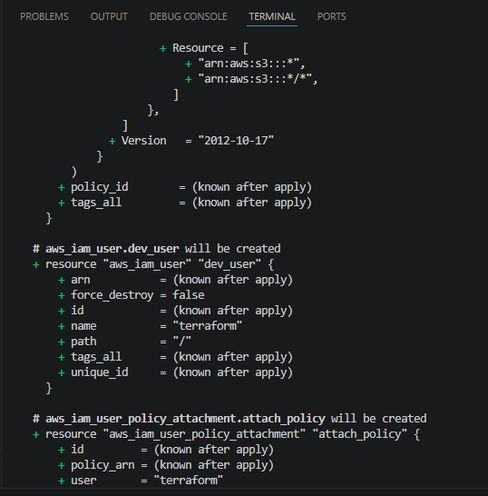
Terraform apply:
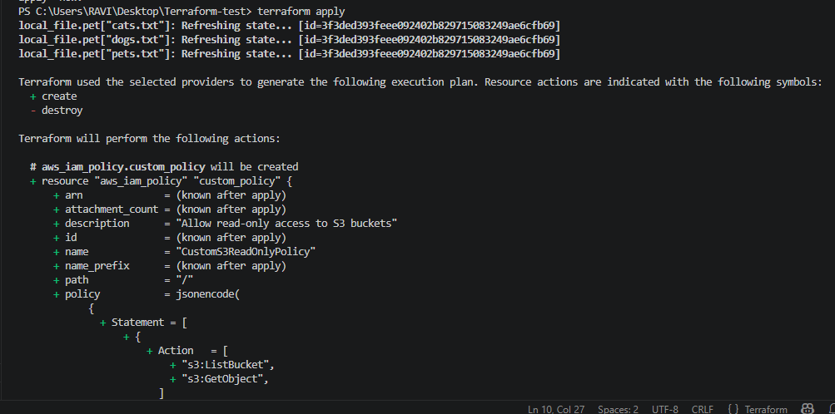
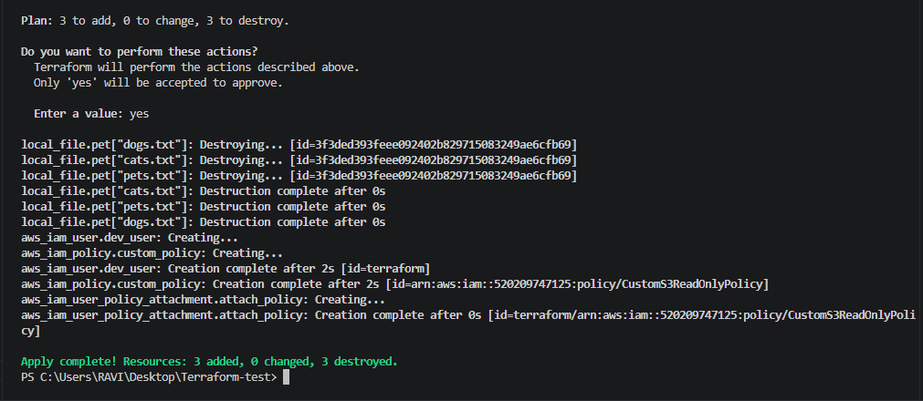
User terraform created successfully:
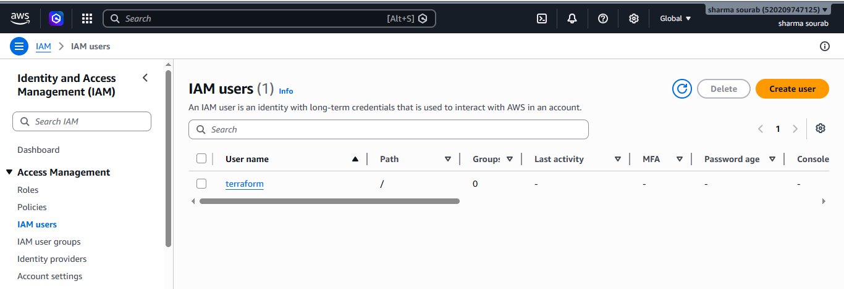
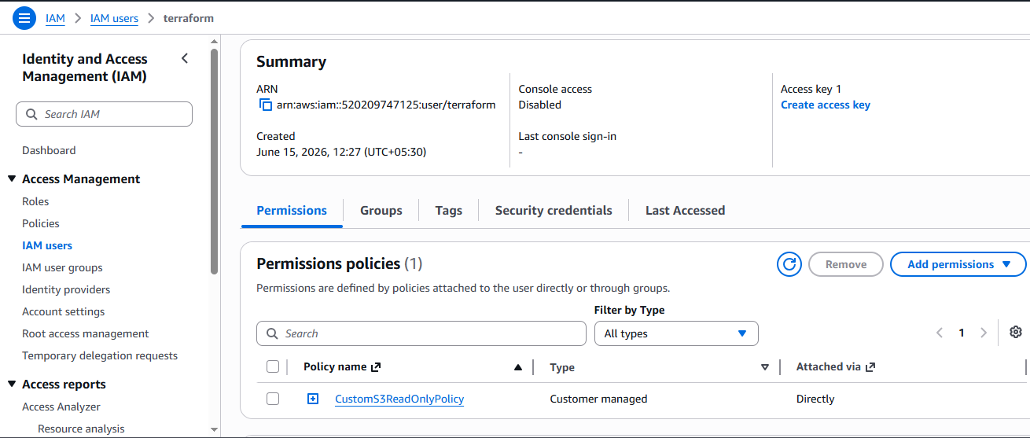
3). Integrate Terraform in Jenkins using the Terraform plugin.
Lets install terraform plugin in Jenkins:
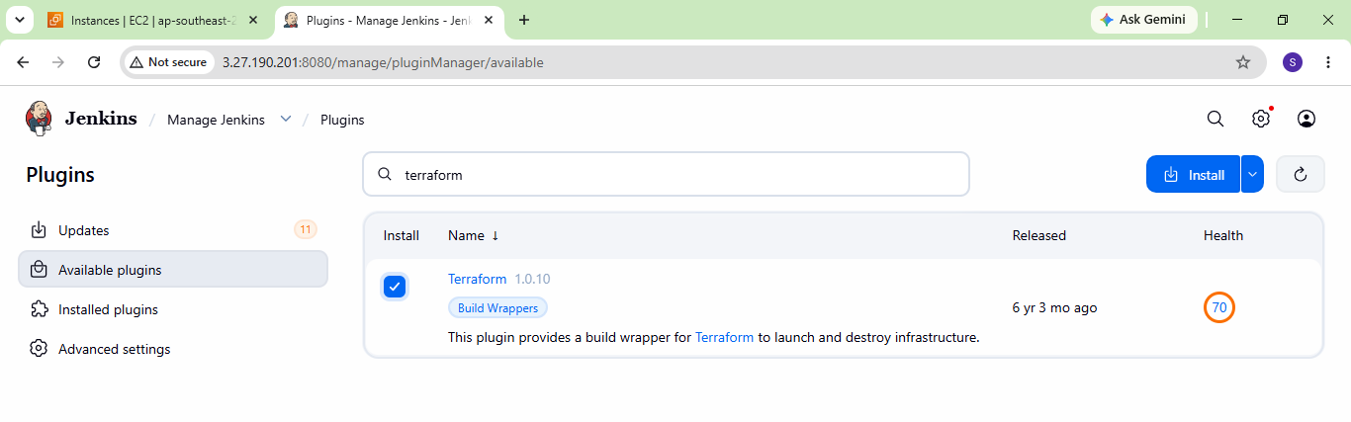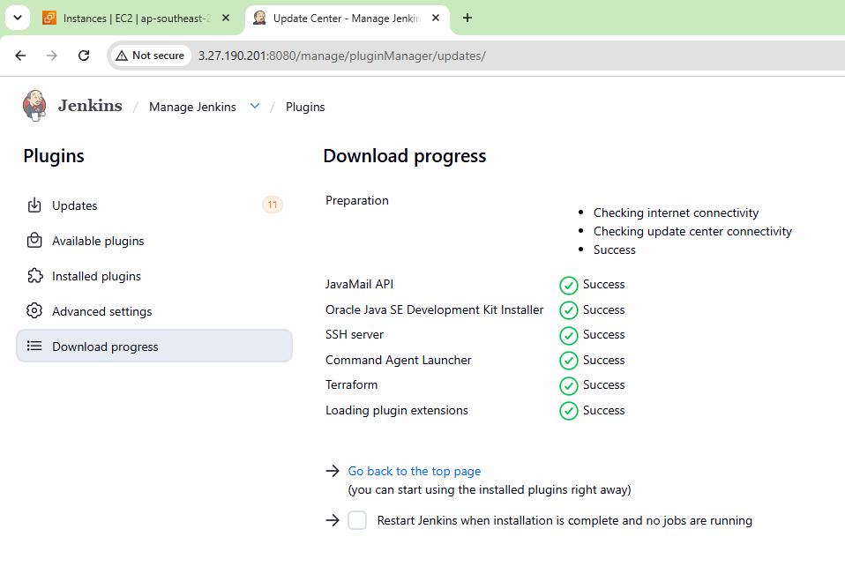
Configure terraform
Tools terraform installation give name save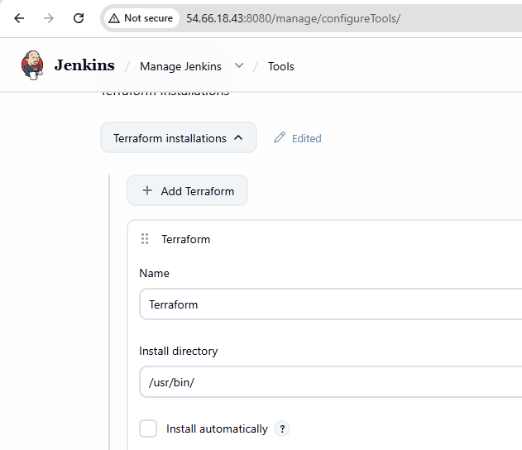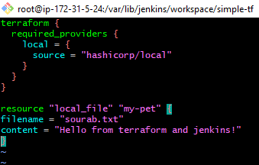
Now lets create a pipeline job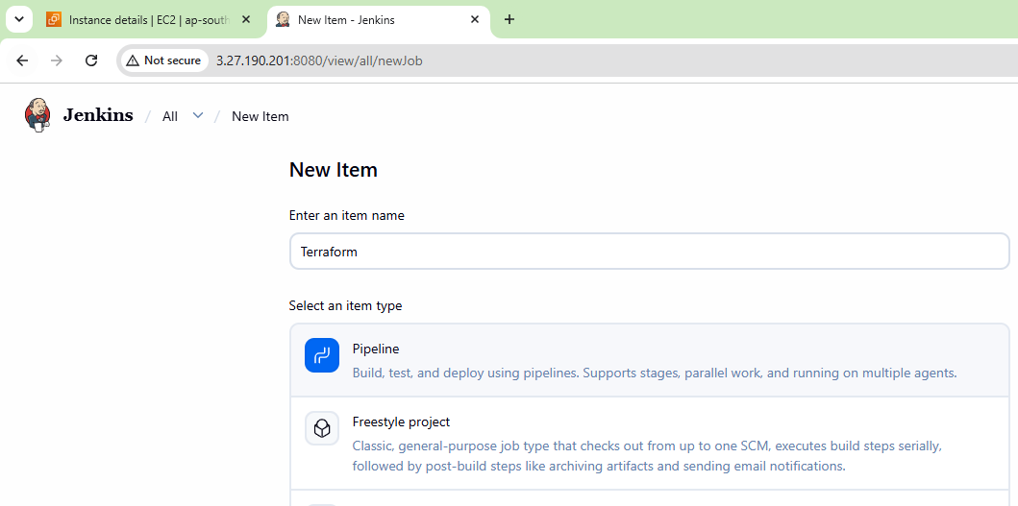
write a pipeline script
pipeline {
agent any
stages {
stage('Terraform Init') {
steps {
sh 'terraform init'
}
}
stage('Terraform Plan') {
steps {
sh 'terraform plan'
}
}
stage('Terraform Apply') {
steps {
sh 'terraform apply -auto-approve'
}
}
}
and successfully executed as well:
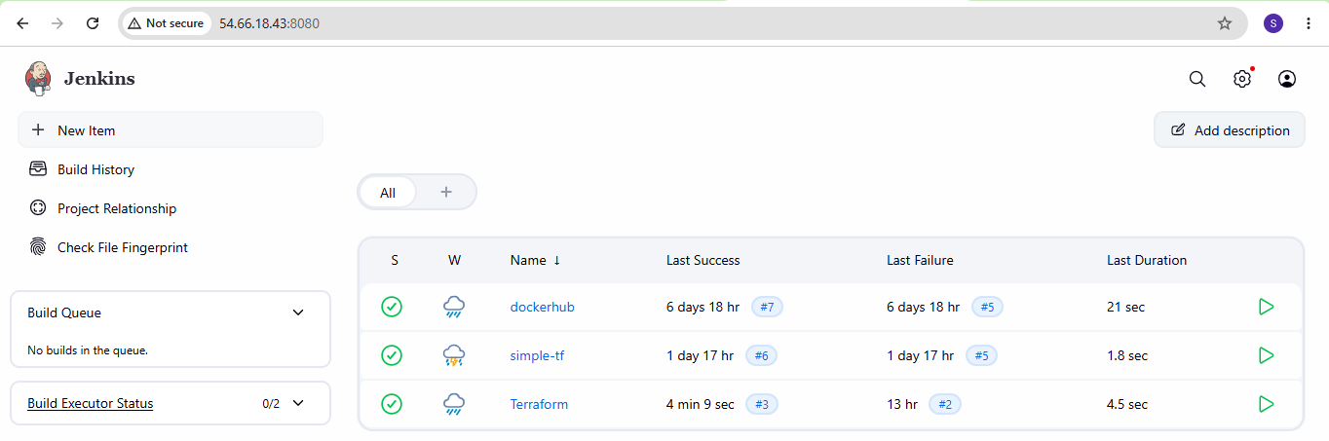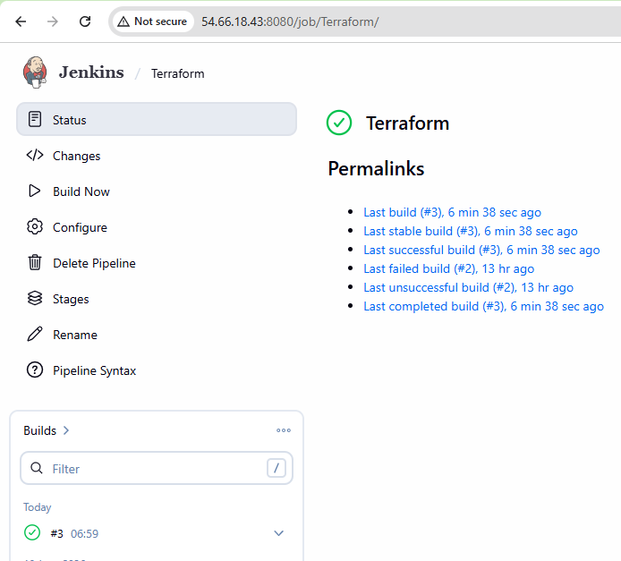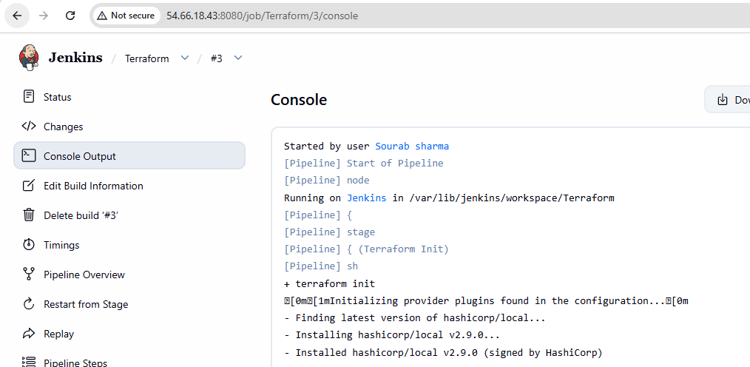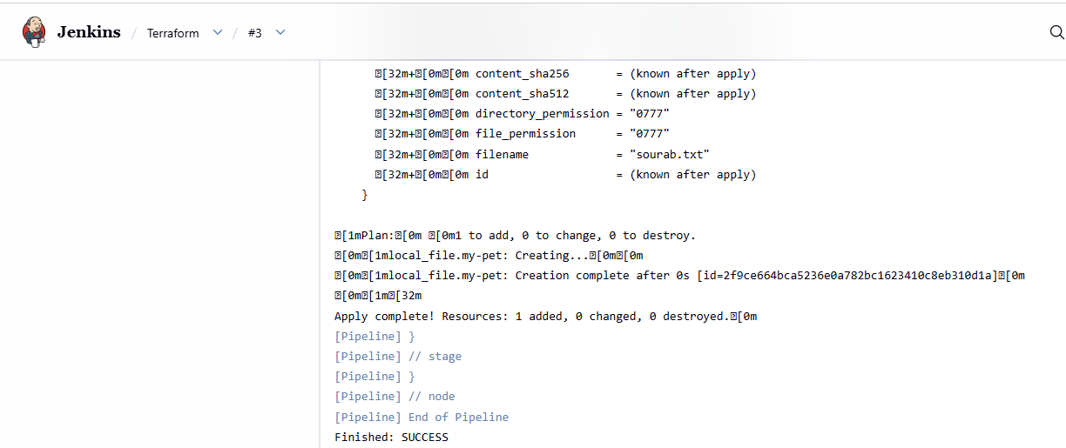 File created successfully:
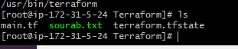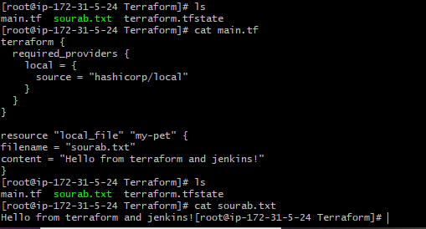
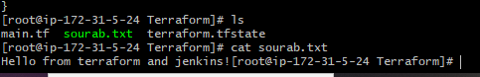
4). Create a CI/CD pipeline for a Nodejs Application: https://github.com/betawins/Trading-UI.git
created a ec2 with ubuntu image and followed as shown below:
sudo apt update
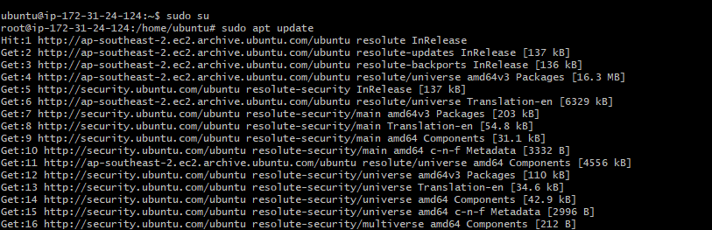
curl -fsSL https://deb.nodesource.com/setup_16.x | sudo -E bash -
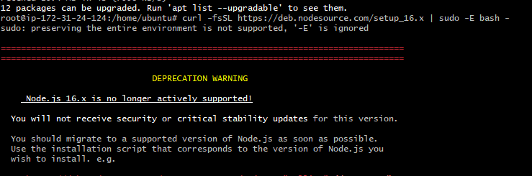
sudo apt install -y nodejs
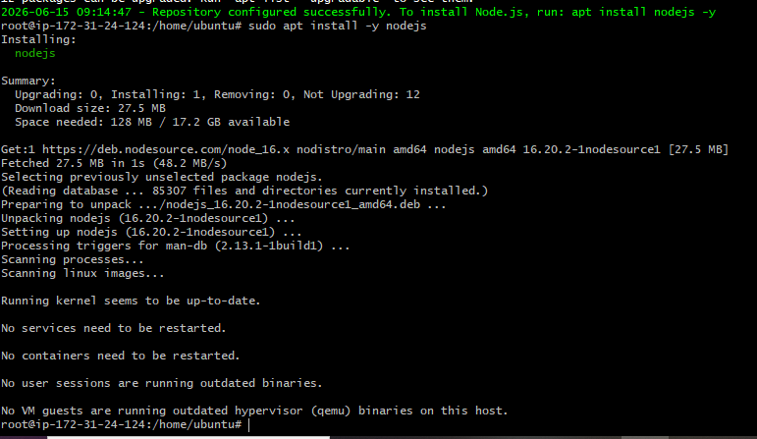
Lets create a pipeline:
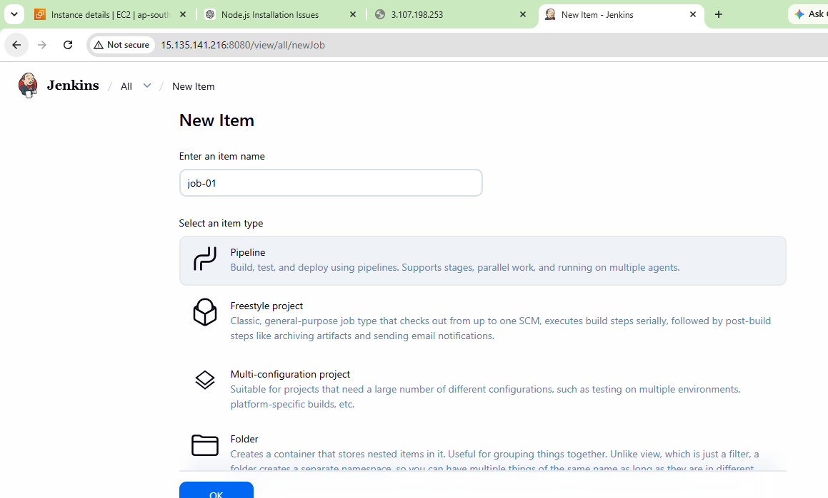
Write a pipeline script:
pipeline {
agent any

tools {
nodejs 'Node16'
}

stages {

stage('Git Clone') {
steps {
git 'https://github.com/betawins/Trading-UI.git'
}
}

stage('Verify Node') {
steps {
sh 'node -v'
sh 'npm -v'
}
}

stage('Install Dependencies') {
steps {
sh 'npm install'
}
}

stage('Build NodeJS App') {
steps {
sh '''
export CI=false
npm run build
'''
}
}
}
}
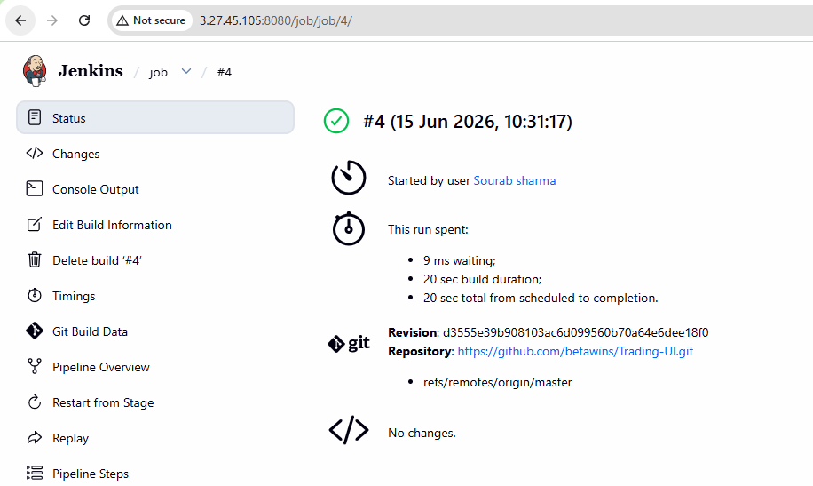
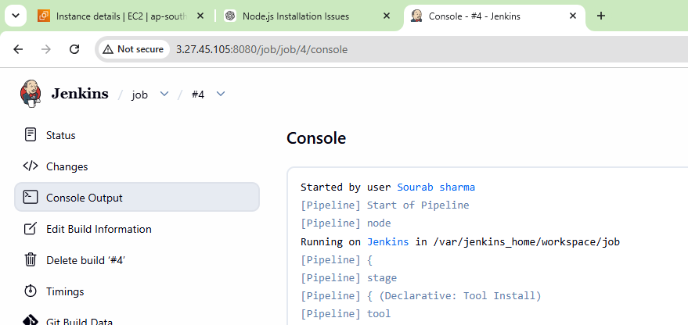
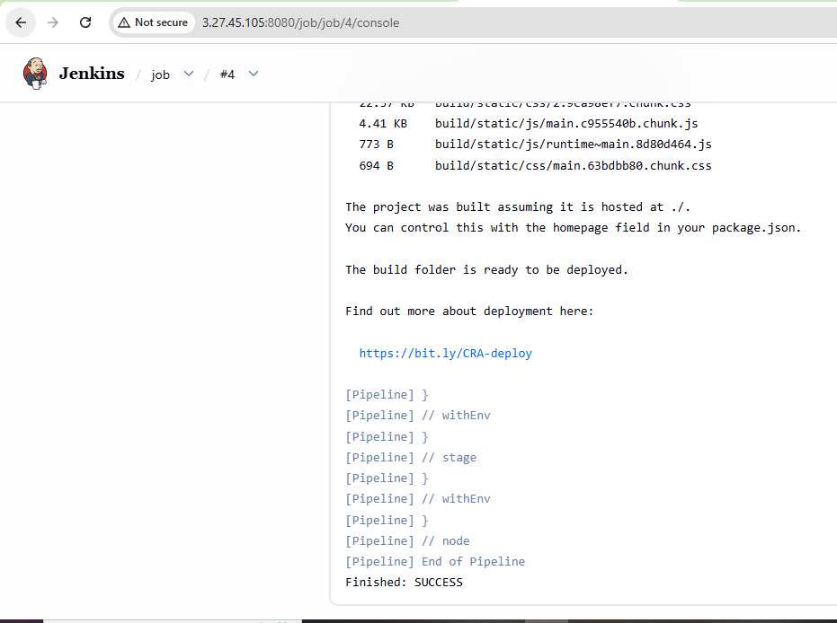
lets verify the package
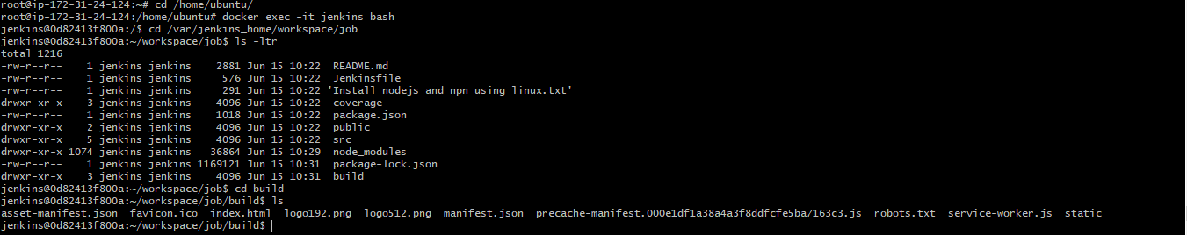
5). Explain 10 Maven commands.
Command Purpose
mvn compile Compiles the source code
mvn test Runs unit test cases
mvn package Creates JAR/WAR package
mvn install Installs package into local Maven repository
mvn deploy Deploys package to remote repository
mvn clean Deletes previous build artifacts
mvn validate Validates project structure and POM
mvn verify Runs checks and integration tests
mvn dependency:tree Displays project dependencies
mvn archetype:generate Creates a new Maven project

